Ho-Chunk Needle
Catalog Number: 66611ab
Accession Number: 28852
Description:
The deer rib needle sharpened at one end with a hole in the center is approximately 2.45 cm wide and 30.5 cm long. The needle is paired with a black calico cloth wrapping the needle. The cloth is 2.5 cm wide and 35.5 cm long with a geometric design on it that includes blue and white flowers along with green dots. There are then speckled white diagonal lines connecting the flowers and the dots. The deer rib needle was originally collected by Adam Thundercloud (a Ho-Chunk elder), was given to Nancy O. Lurie as a gift, and was later donated to the museum in 2000. The needle originated in Black River Falls, Wisconsin.
The original deer bone had to be grooved with a flaking tool which could be done with a rock surface, hammerstone, and sanding it with sandstone chunks to get a clear point and a needle shape. The process could be made easier by first soaking the bone in water for a few days to soften the bone material. The bone material would then harden again after being flaked and dried out. This process of flaking and sanding the bone to make a smooth needle, gradually alters the bone into a useful sewing utensil with the curved needle, a hole (in this case in the center of the needle), and a sharpened point at the end. The calico cloth paired with the needle, was used to keep the needle dry as well as prevent any damage to the needle.
The thicker bone needles were commonly used for sewn cattail matts. The curve in the needle was also a key aspect to the needle because the worker would not have to lift the cattails too far off the ground. This type of needle would not be effective for sewing with more delicate materials including embroidery, beadwork, or ribbon-work due to its size and thickness.
View 1 View 2
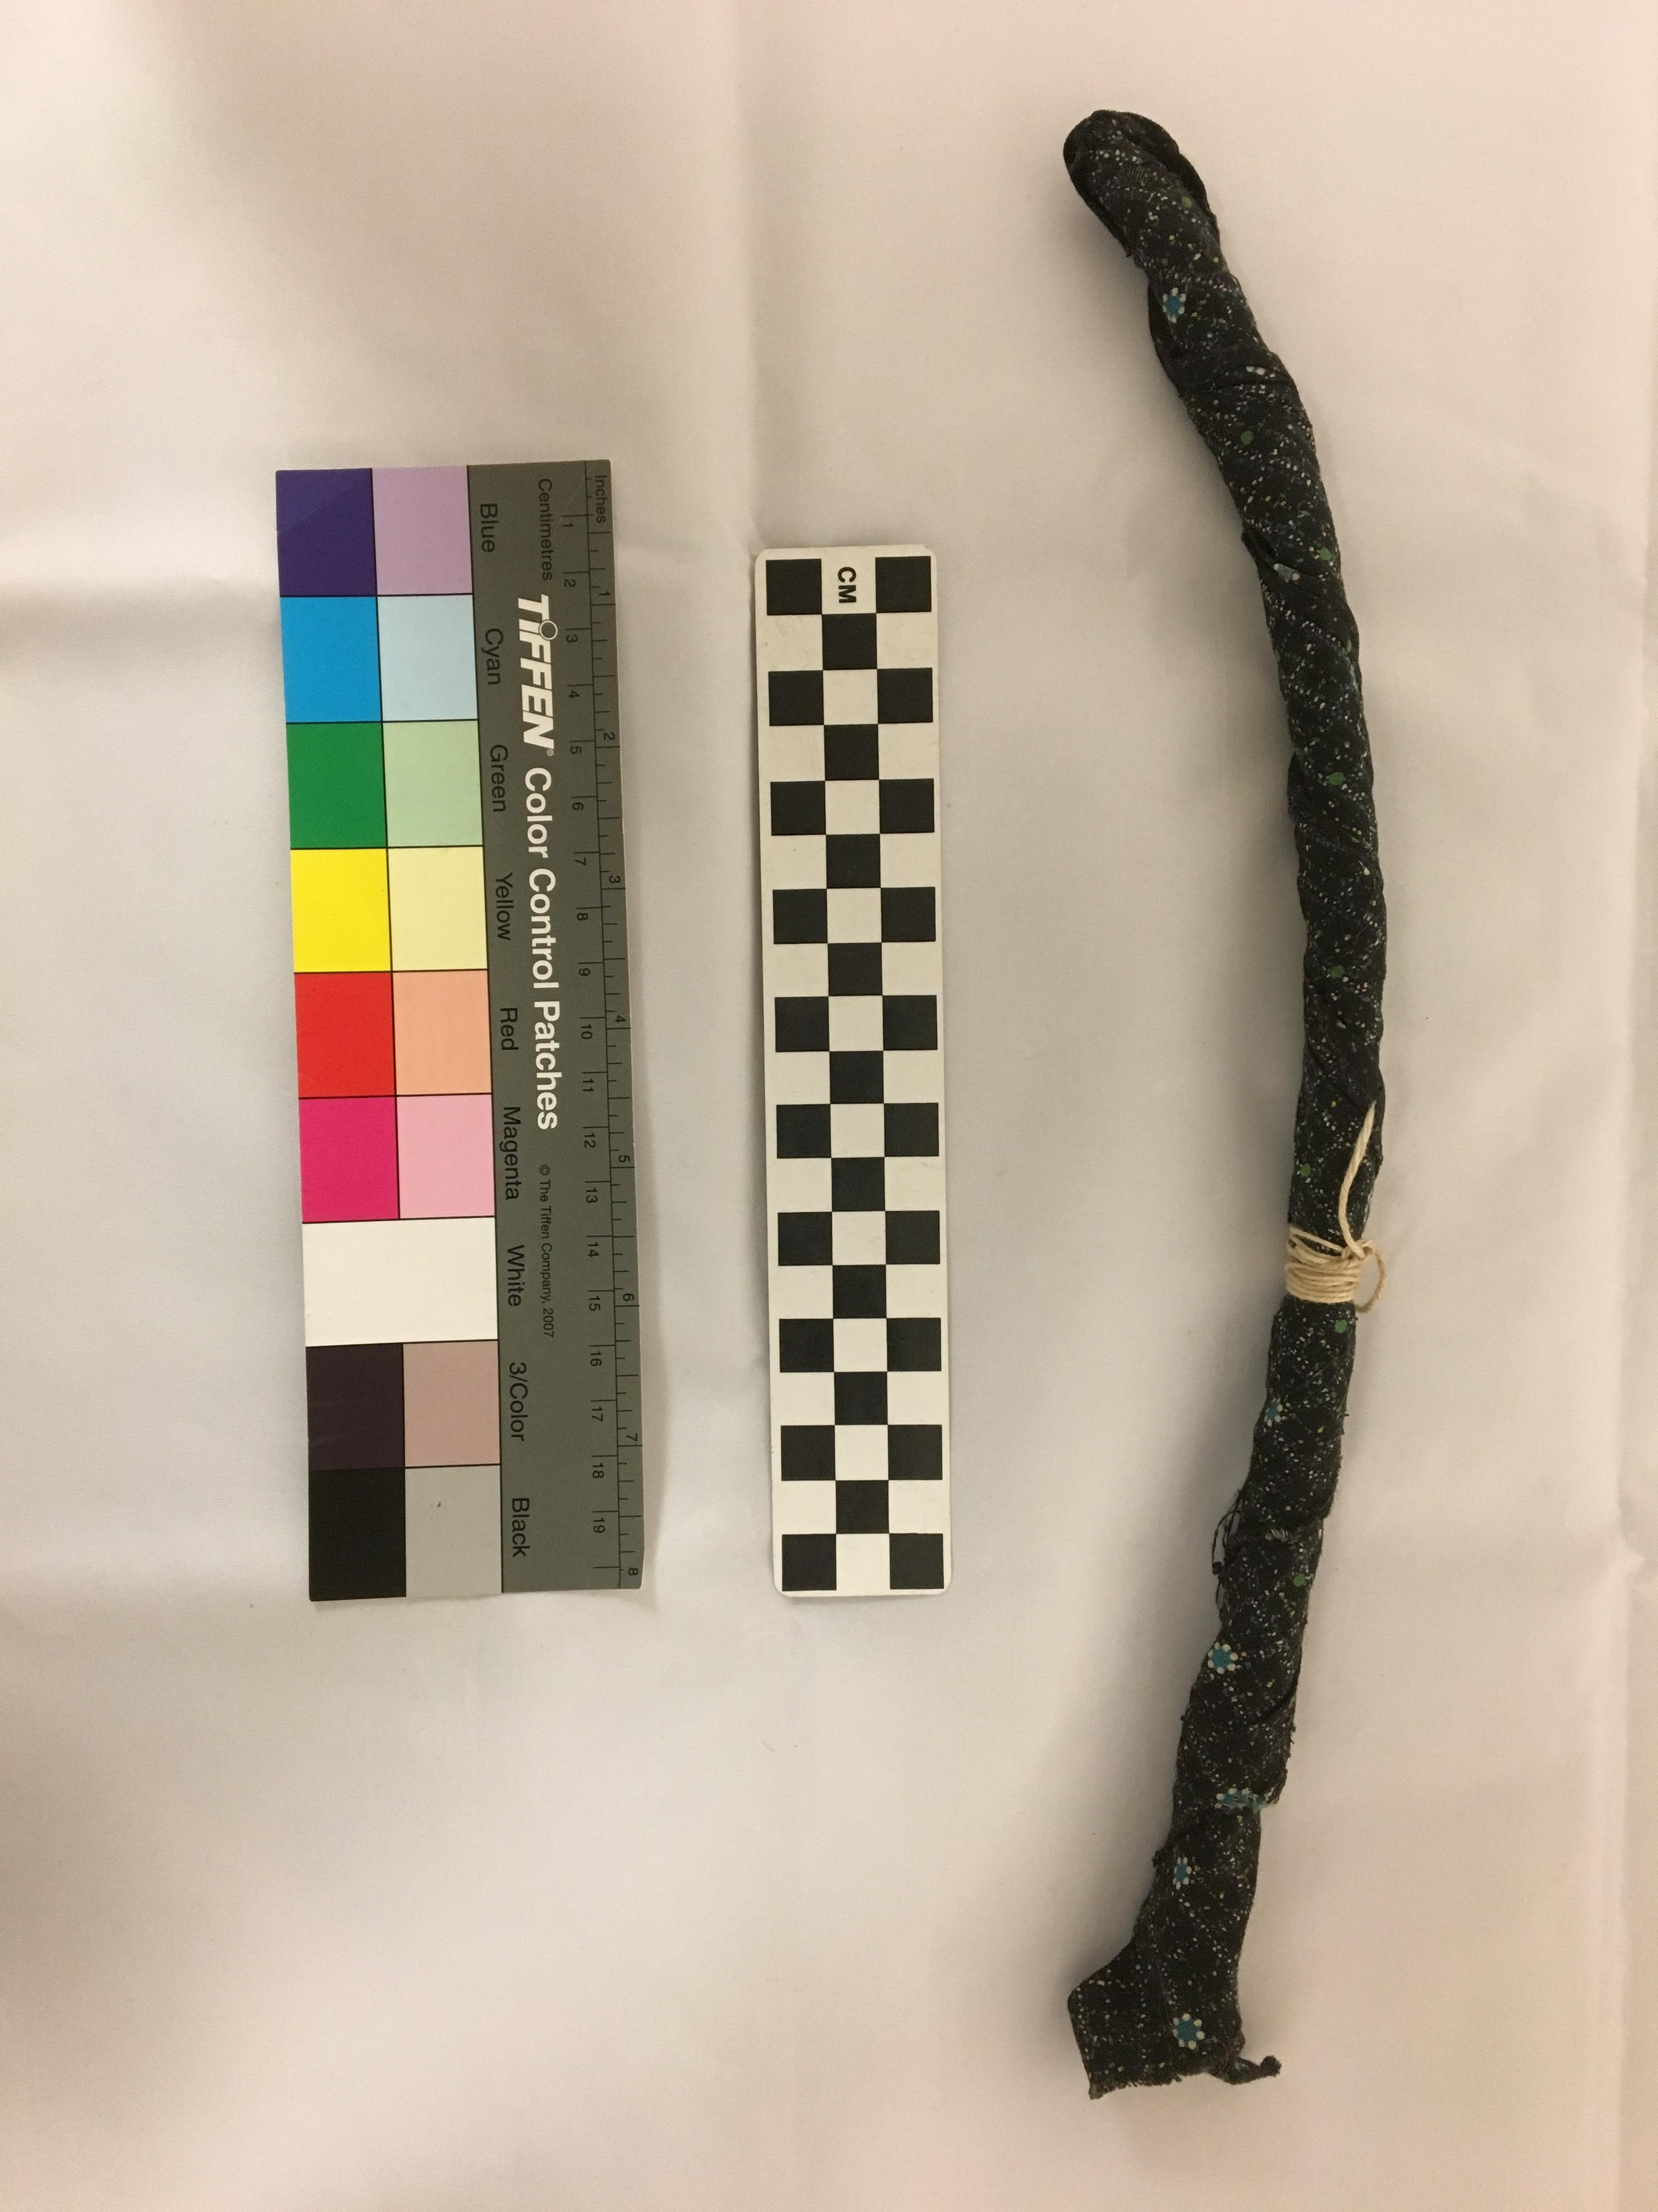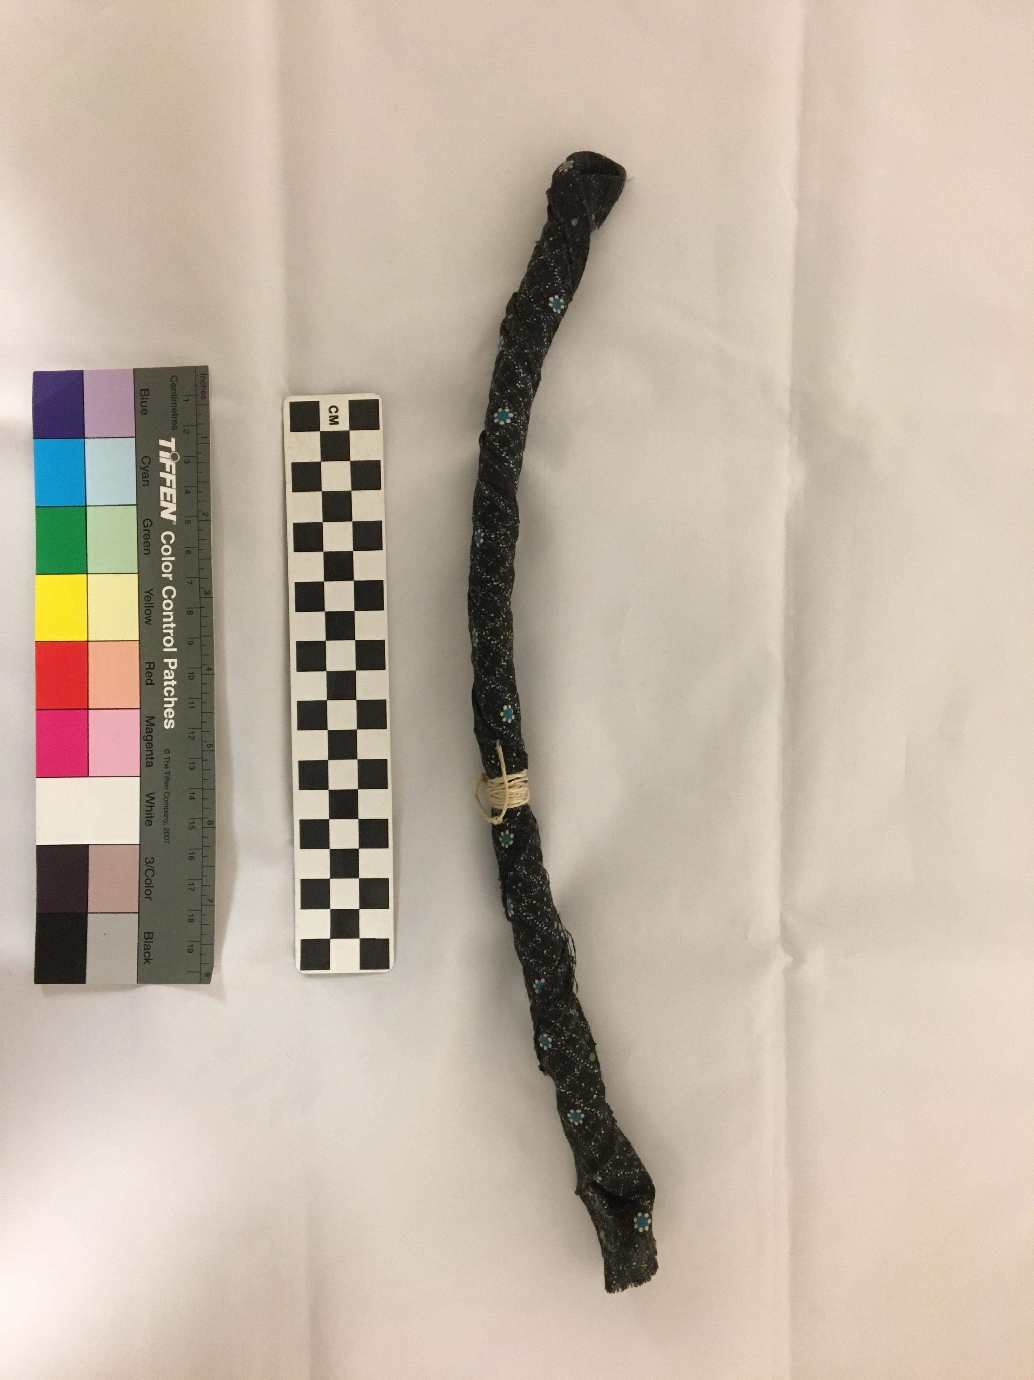

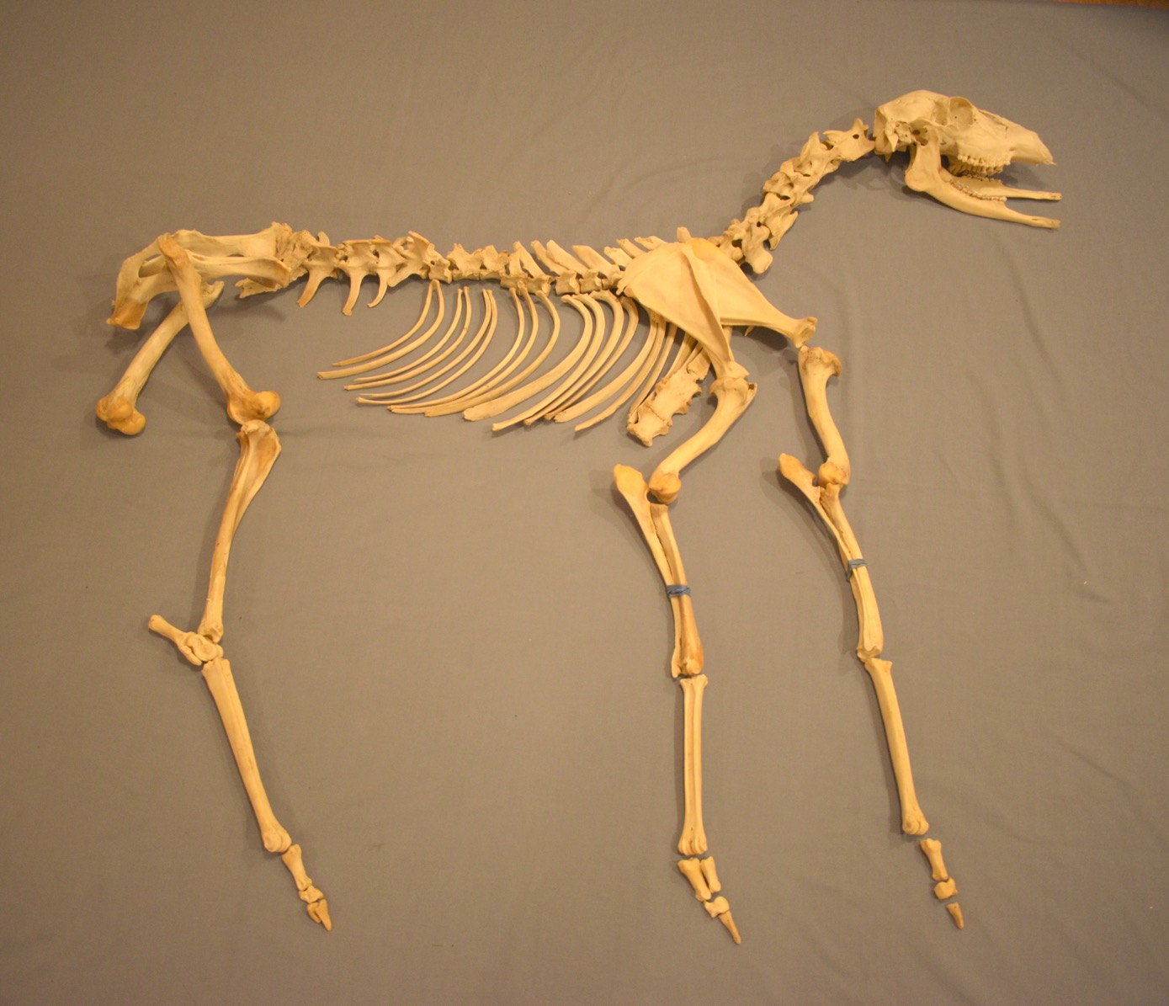
http://www.mpm.edu/content/wirp/ICW-52.html
http://www.mpm.edu/content/wirp/ICW-38.html
http://www.oshkoshmuseum.org/Virtual/PeopleoftheWaters/vex35/7A987010-2C16-4295-877E-293346749423.htm
https://archaeology.uiowa.edu/bone-tools-0
https://www.nps.gov/katm/blogs/what-does-a-bone-needle-say.htm

Ho-Chunk Cup and Pin Game
Catalog Number: 14648
Accession Number: 3964
Description:
The deer bone game consists of seven conical bone pieces on a thong with a wooden pin attached to one end. There is also a leather disk with 4 perforated strips at the other end with 8 holes on the closest strip to the bones, 7 holes on the one above it, 5 on the one above that, and 4 on the top strip of leather. It was originally collected and donated by anthropologist Dr. Paul Radin and was received by the museum in 1914. This game set originated in Black River Falls, Wisconsin.
These game pieces make up the cup and pin game with variations of the game being called the ring and pin game, the cup and pin game, or the bone game. The game is played by tossing the leather in the air while holding on to the pin. While the leather is in the air the player must put the pin through on of the holes in the leather. The player can also catch the bones on the pin with more points awarded for more bones caught on the pin. The player must repeat this action until they miss the bones and the leather. Once the player misses a hole in the leather or the bones the cup and pin are passed to another player. This type of play continues until one of the players reaches a pre-determined number of points.
This game was played by both men and women. It has also been likened to the European game of cup and ball toss although the cup and ball toss was a less complicated game. The cup and pin game was widespread throughout North America with different variations of the game. The game had variations with different types of needles with bone, wood, or eventually metal darning needles being used. The bone pieces on the string/throng also had variations with thimbles replacing the bone pieces with increasing use of thimbles.
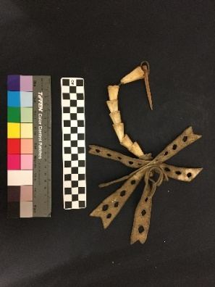
--ideas for what to write description on
What is unique about this set/Ho-Chunk version? (if anything?)

Ho-Chunk Pipe Stem COMPLICATED!!!
Catalog Number: 40760
Accession Number: 11492
Description:
This smoking pipe stem is made of wood and includes carvings of a frog, turtle, hummingbird, and beetle. The frog and the turtle are on one end of the pipe with the hummingbird and beetle on the other. The pipe stem has two moveable rings at the center of the pipe stem that have red on them. There are also highlights of red on the edges and figures of the animals. The pipe stem is 34 cm long by 2.3 cm wide. The carved stem belongs with item 39623 which is a catlinite, a red stone also called pipestone from western Minnesota, pipe. Catalinite was commonly used for pipe bowls and was often paired with a wooden carved pipe stem. This smoking pipe stem is part of a calumet otherwise known as a “peace pipe” because of the long stem attached to a bowl rather than a smaller one-piece pipe or stone. It originates in Minnesota where it was collected and later donated to the museum by museum trustee George A. West. The pipe stem was received by the museum in 1934.
The Ho-Chunk origin story incorporates the use of tobacco into the foundation of the earth. The Earthmaker gave the chiefs tobacco with the message to grow it and if you offer it to the Earthmaker he will accept it and give them what they asked. Along with the gift of tobacco the Earthmaker gave the chiefs fire so that they could live on Earth. The offering of tobacco either dry or from smoke was able to ensure communication with the spirits. Gifts of dry tobacco were often exchanged between people for special occasions.
Side 1 Side 2
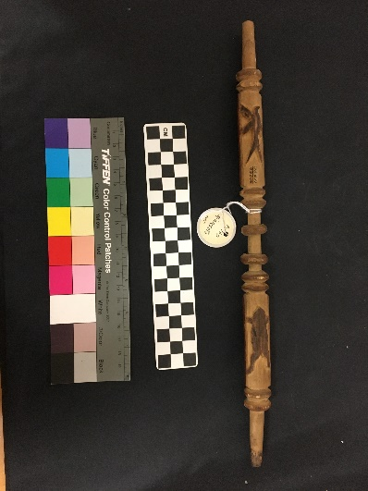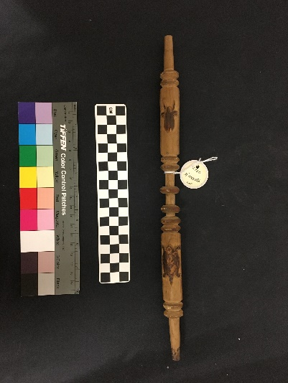

Source information/research
http://www.mpm.edu/content/wirp/ICW-140.html
https://lacrossetribune.com/news/local/things-that-matter-ho-chunk-ceremonial-pipe/article_74460918-d65a-527d-9407-7aff1aca5ff7.html
http://www.native-languages.org/pipes.htm
more research into the catlinite pipe as well as sourcing COMPLICATED!
catalinite pipe from Mrs Bigthunder who claimed the pipe had been in her family for many generations the catalinite pipe was on exhibit
Catalog 40760 Accession 11492
Also given to museum by george a west but in 1932 and collected by Mrs Bigthunder had been in her family for many generations according to her and was bought by George a west and given to mpm
Catalinite pipe bowl has elbow shape with excised stars, turtles, and deer head, top of bowl is burnt it is 5.5cm by 3.5 cm
Originates in Wisconsin?
https://books.google.com/books?id=1Nj2CwAAQBAJ&pg=PT125&lpg=PT125&dq=ho+chunk+bigthunder&source=bl&ots=xc0e08Vu5P&sig=Ne9XFJts9-e7HdrGfpDPZORxdGk&hl=en&sa=X&ved=2ahUKEwiiqdHbrtvdAhUm6YMKHUX4AikQ6AEwBnoECAMQAQ#v=onepage&q=ho%20chunk%20bigthunder&f=false
https://www.wisconsinhistory.org/Records/Article/CS334
https://www.wisconsinhistory.org/turningpoints/search.asp?id=1654
http://content.wisconsinhistory.org/cdm/ref/collection/tp/id/28303
http://wigenweb.org/shawano/1910_HOCHUNK.html Bigthunder family names with relationships in 1910 census might not be relevant?
Ho-Chunk Wampum Necklace
Catalog Number: 14638
Accession Number: 3964
Description:
The Wampum necklace is made of textile, brass, and shell. The necklace is 28 cm long with long shell beads strung together on a string with brass beads separating the shells. The necklace has 18 shell beads and 15 brass beads on the necklace. This Wampum necklace includes brass beads from trade with Europeans while the wampum beads would have been from trade with other natives. It was originally collected by anthropologist Dr. Paul Radin and was received by the museum in 1914.
Wampum beads originated in the Northeastern woodlands of the United States, the area between Virginia and Maine going west towards the Great Lakes, and were traded inland at an increasing degree with European settlers and fur traders in exchange for fur pelts in the Great Lakes area. The beads are made from a whelk shell that tends to be in a spiral shape or a quahog otherwise known as a Western North Atlantic hard-shelled clam. The shells consist of purple and white colors that were used to make wampum beads. Traditionally the purple beads were worth twice as much as each white bead. The wampum beads were shortly considered formal currency with the Massachusetts Bay Colony in 1650 where strings of beads had an exchange rate with eight beads equaling one British penny and purple beads were valued at twice the price of white beads. This exchange; however, was only considered valid currency until 1661when the Wampum Valuation Law was repealed. Other areas of the Northeast also had an established value for wampum beads but the use of the beads as currency died out in the early eighteenth century.
Wampum beads were used not only for necklaces and adornment but also as wampum belts. The wampum belts were used for histories, storytelling, treaties, and ceremonies. Wampum beads are still used as forms of adornment by some Native people in the woodland area. Some tribes also consider wampum to be an important item that signifies Native identity which has led the Milwaukee Public Museum to repatriate wampum to the Stocksbridge tribe.
Wampum beads were made by first breaking the shell into small blacks. The shell pieces were then drilled into by a stone or reed drill. The block had to be drilled to the center in each direction rather than straight through. The block was then rolled or rubbed against a stone to form the final shape. The beads were then strung together on plant fibers, sinew, or string to form the final product, in this case a necklace.
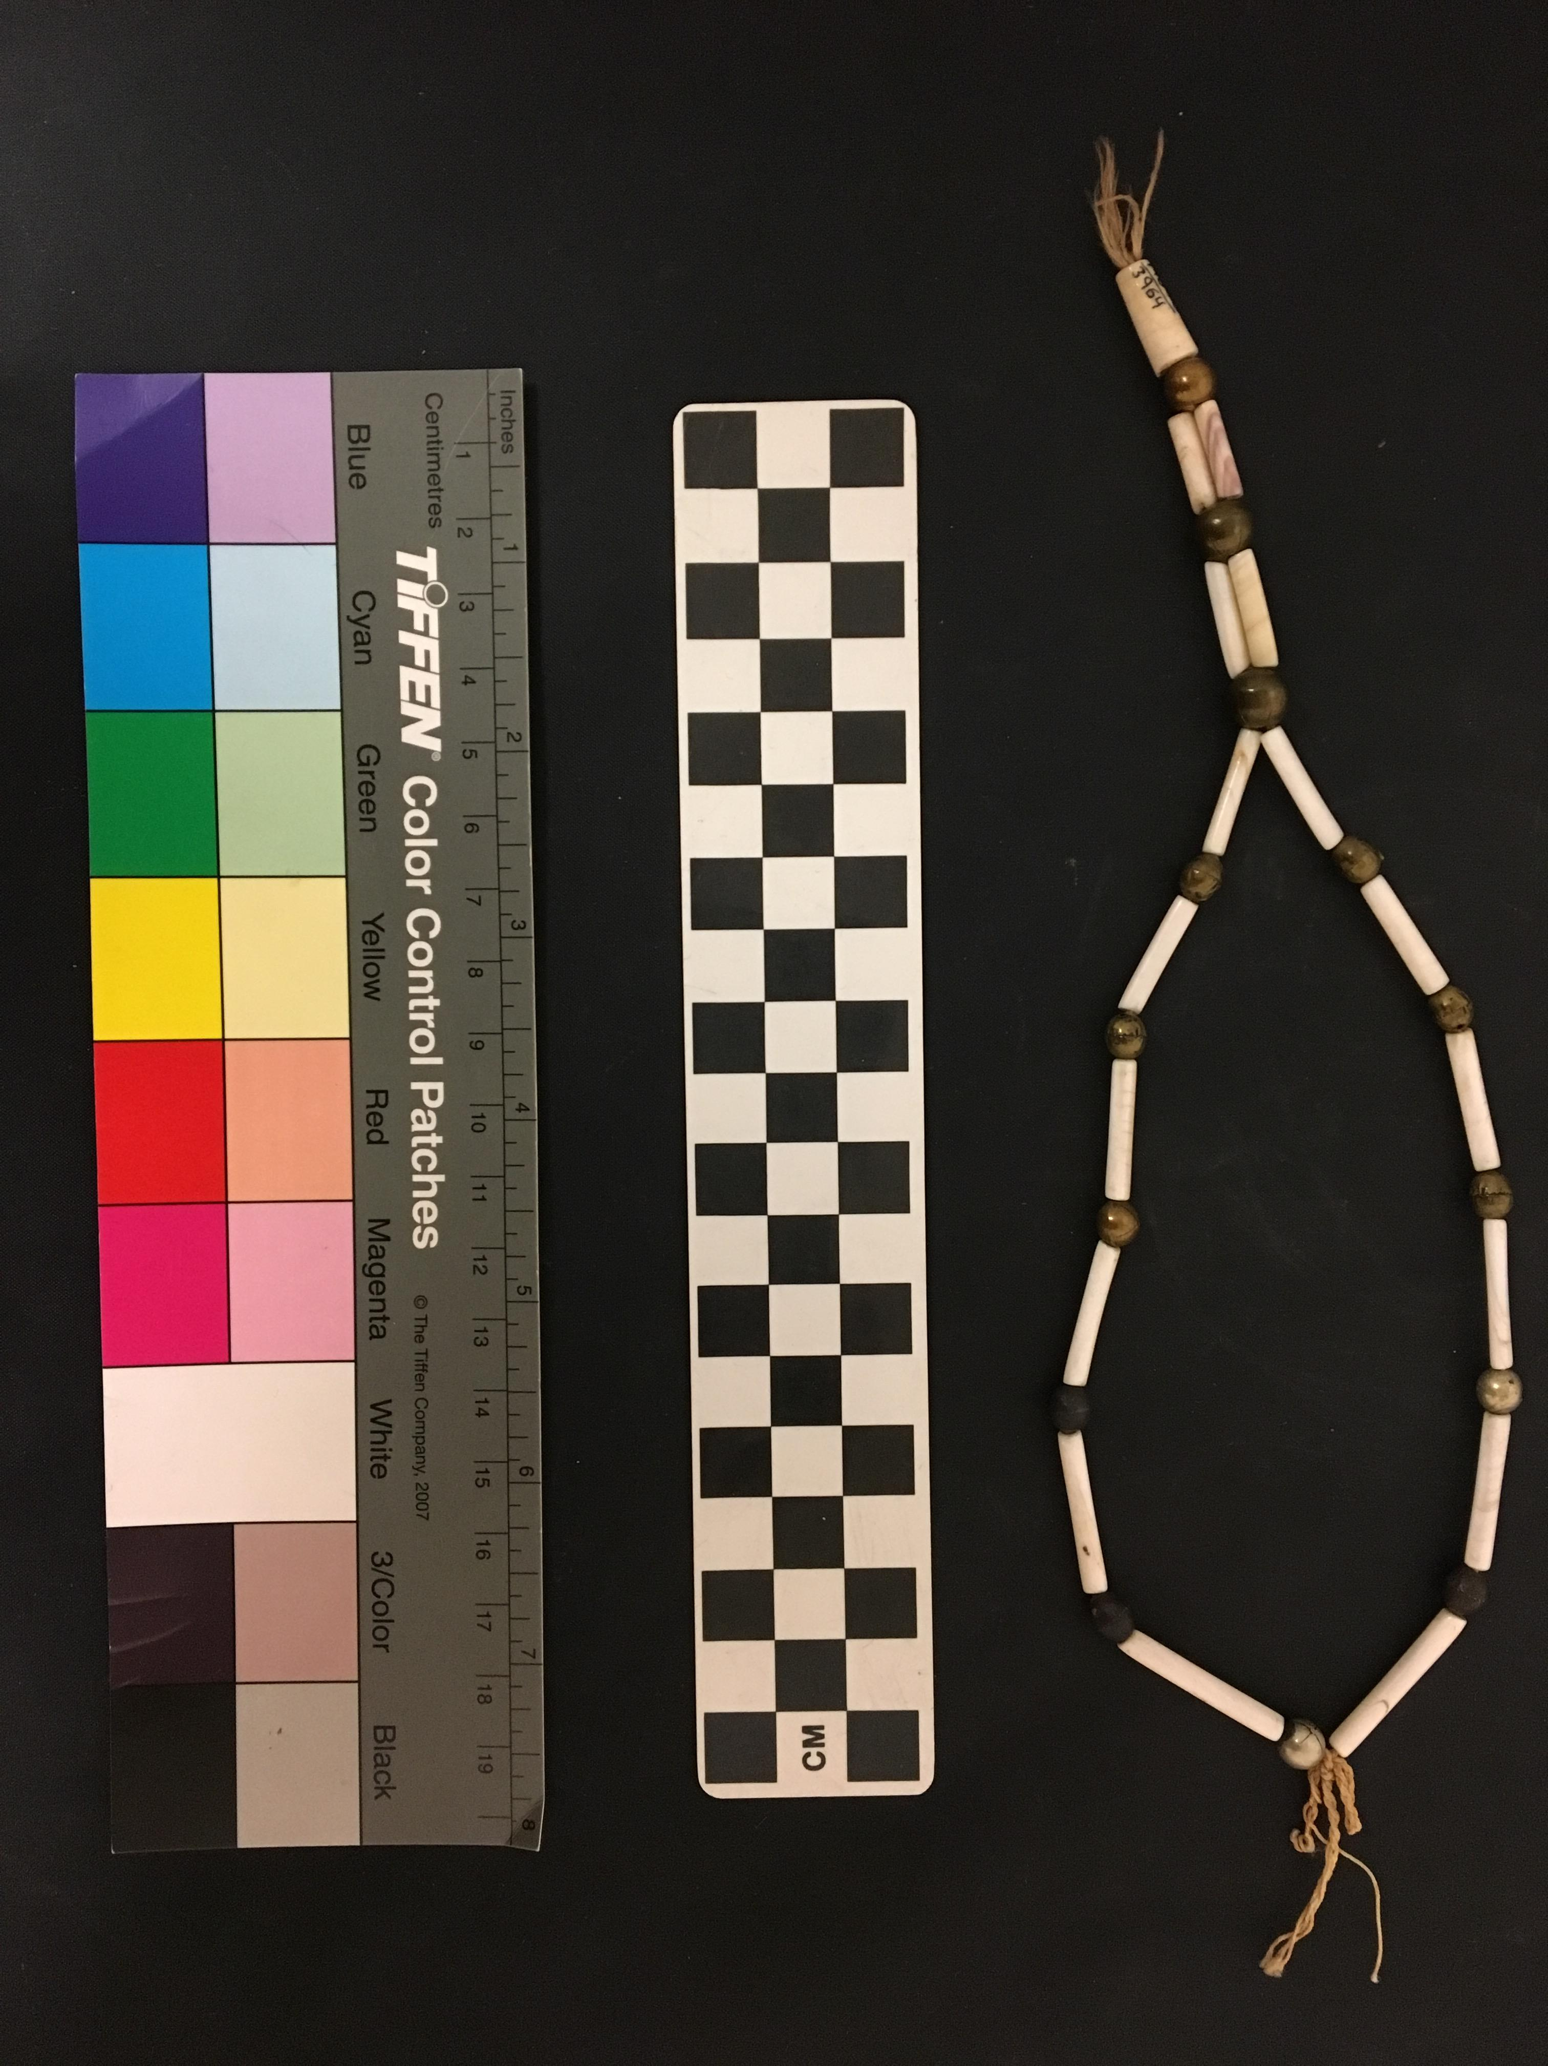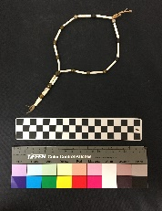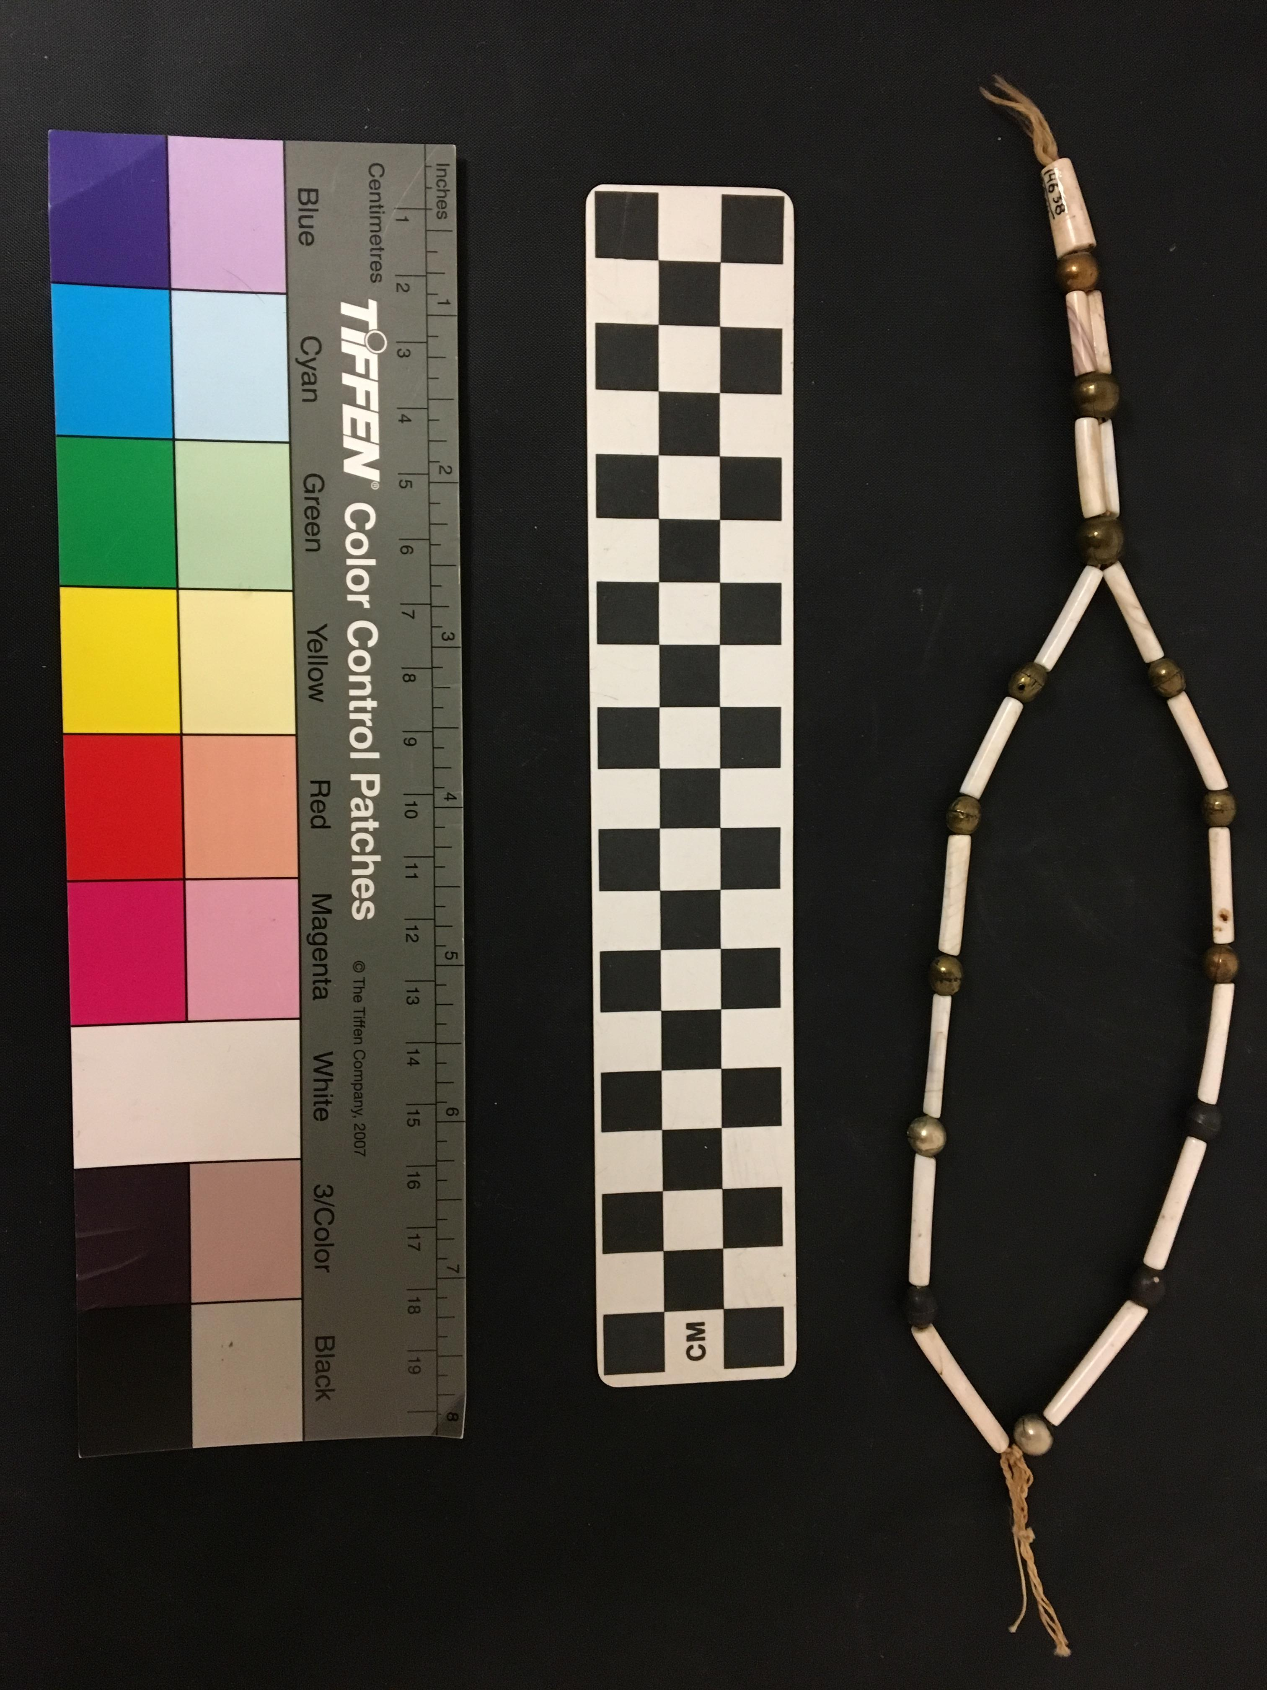
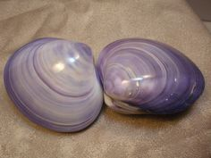
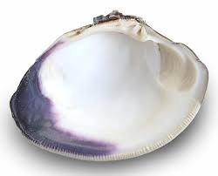
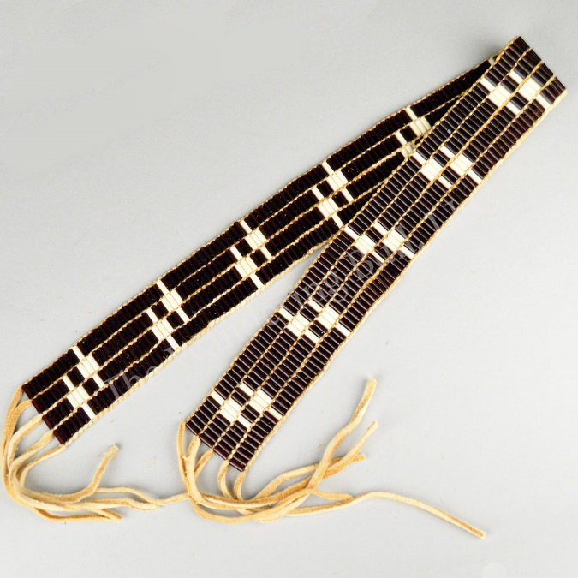
Notes/sources for necklace information
http://seahorsedesignjewelry.com/history-of-wampum.php
https://www.wisconsinhistory.org/Records/Image/IM62299
https://wanderingbull.com/wampum-beads-history/
https://newsmaven.io/indiancountrytoday/archive/from-beads-to-bounty-how-wampum-became-america-s-first-currency-76Ql3IPA2kKpBqfHiggjXw/
https://www.iamanishinaabe.com/creative-process/

