MPM Education Department Teaching Collection
Artifact Identification worksheet

Date: 11/29/18 Reviewer: Alex Warren
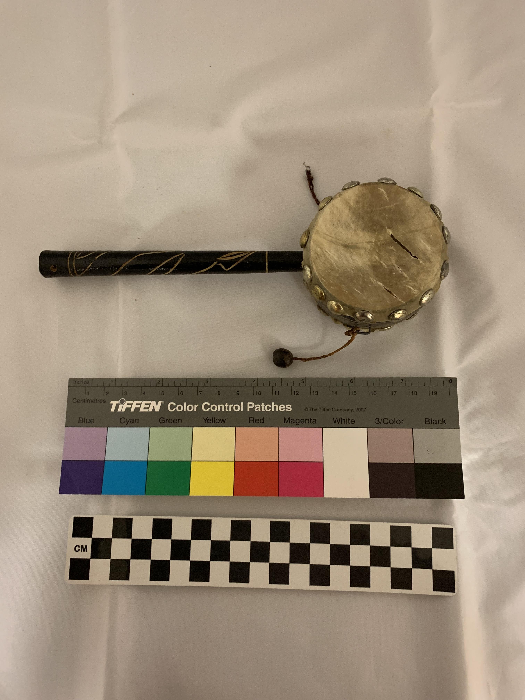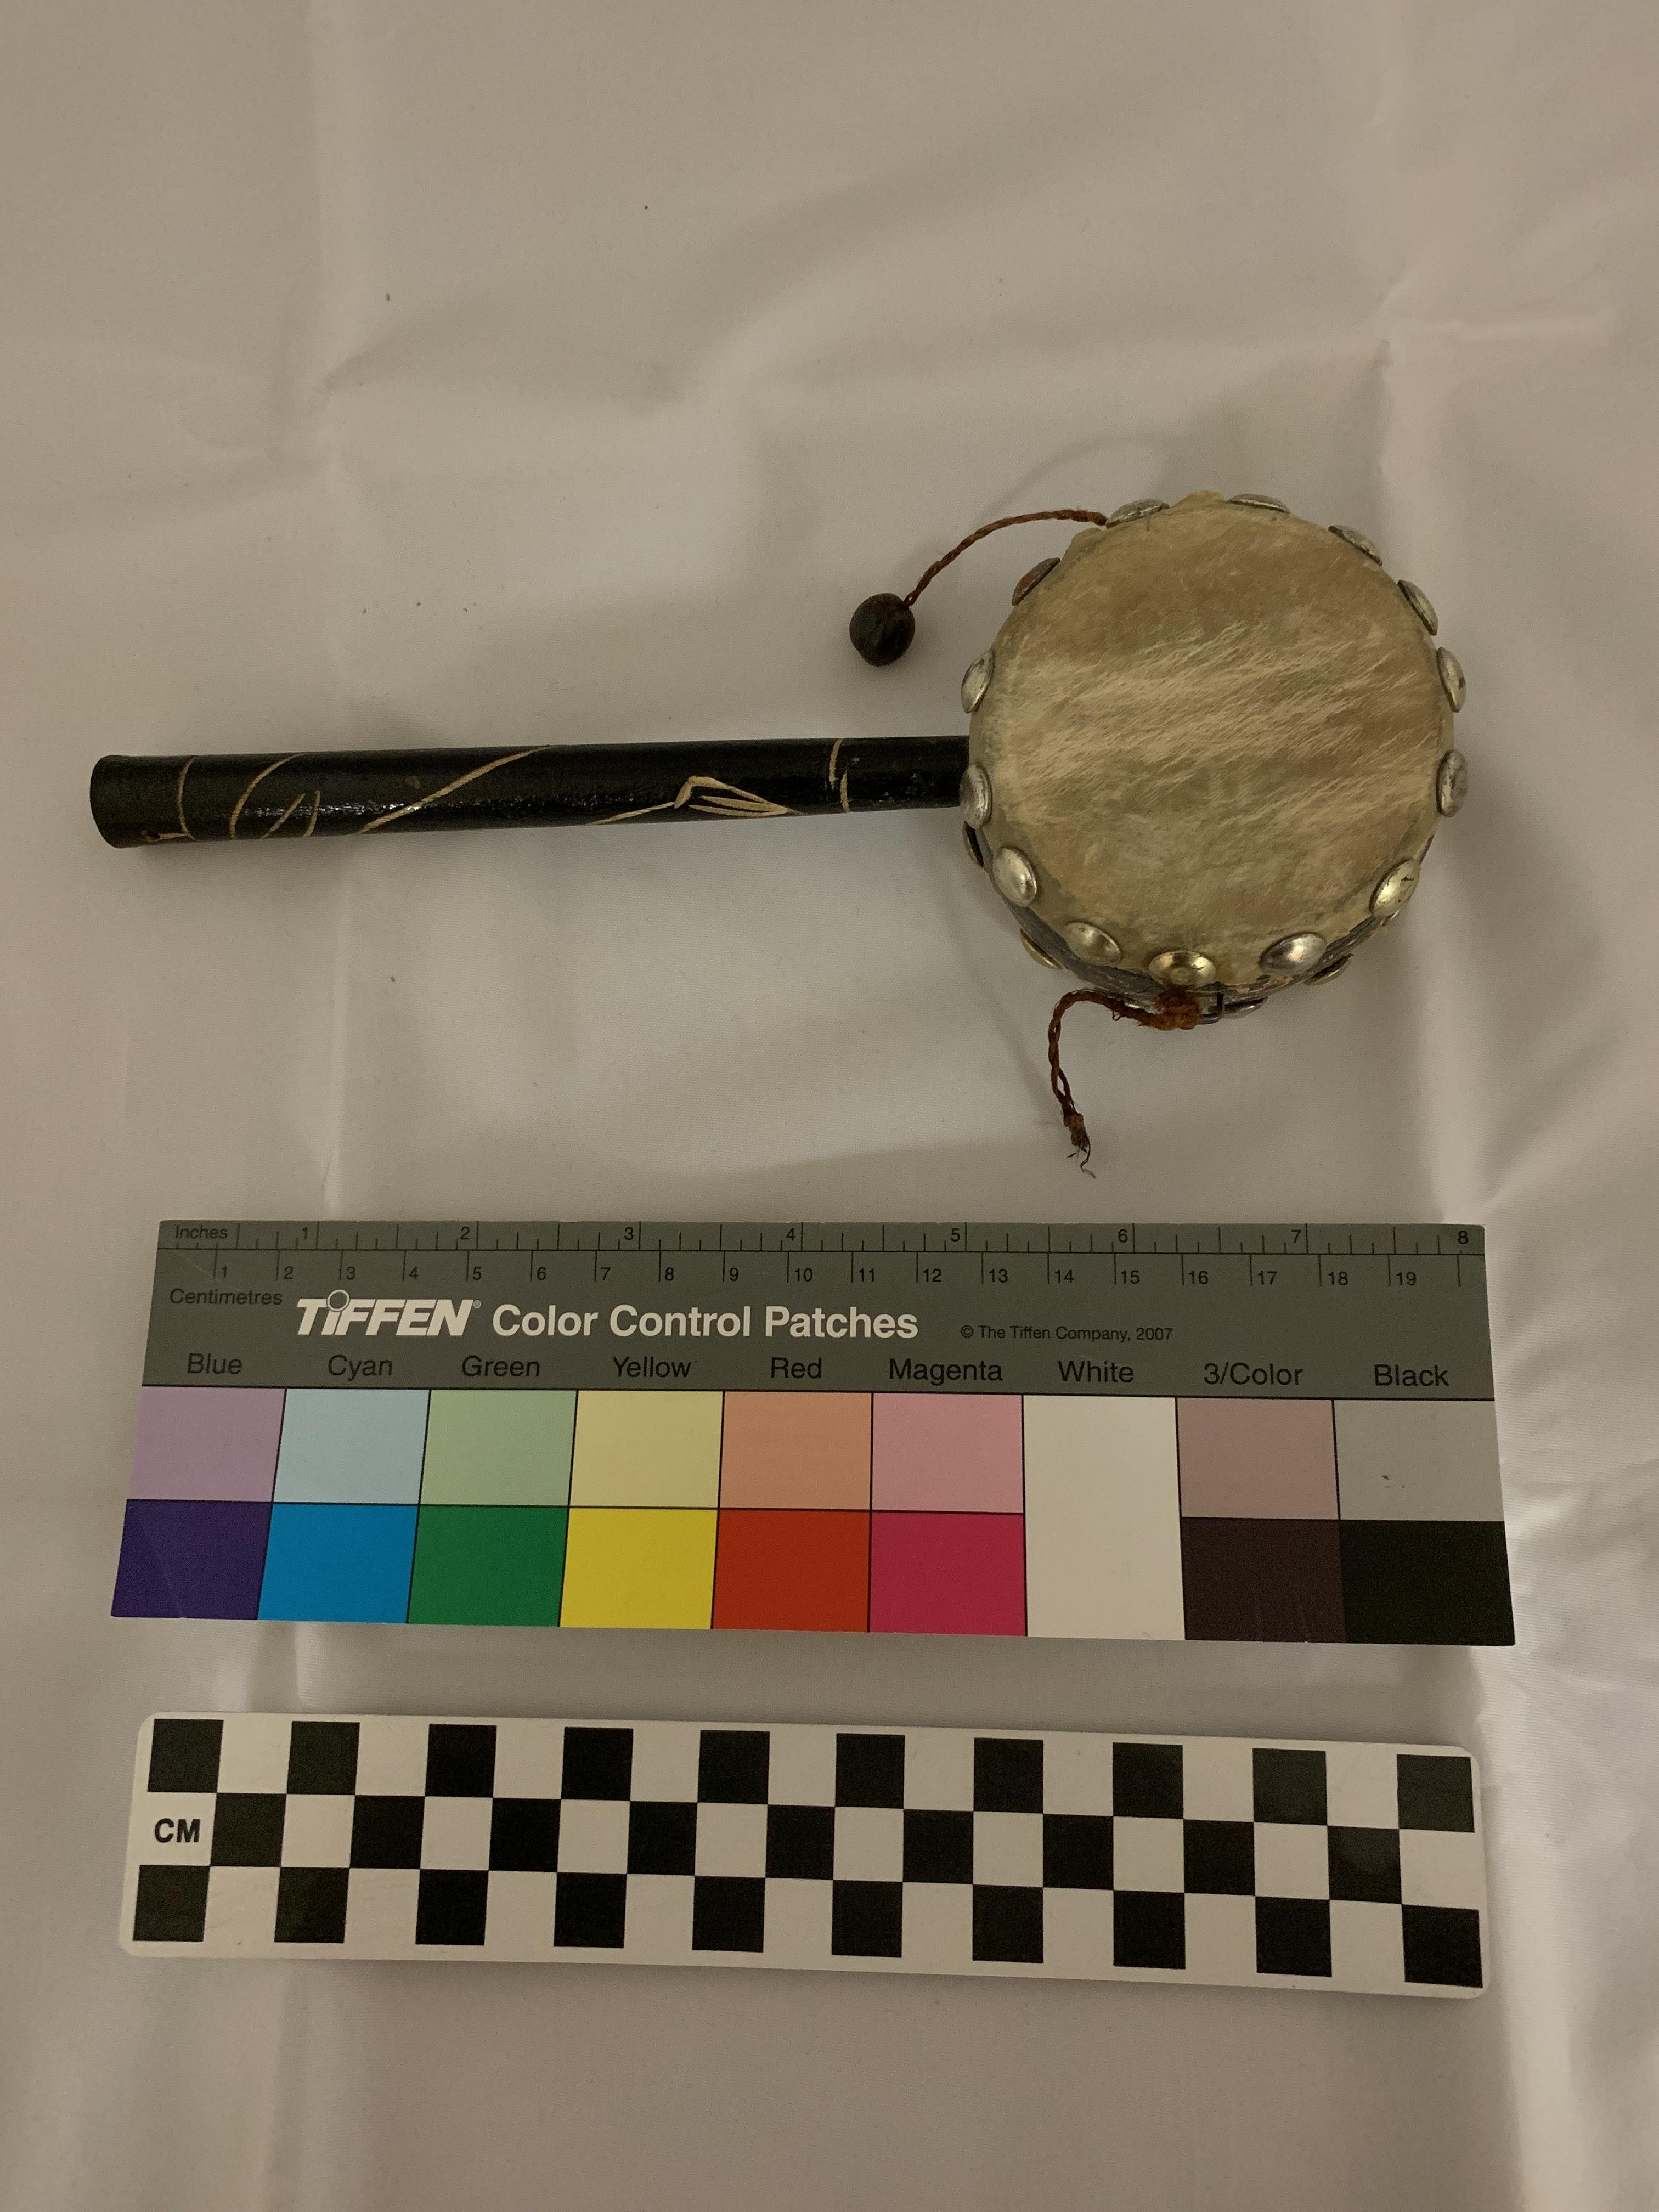
Object number: no number
Object name: Den Den Daiko (rattle drum)
Country: Japan Time period: 1920s-1930s
Authenticity:
Exactly resembles common Japanese Den Den Daiko drums. I found multiple that looked exactly the same.
Recommendation:
This is a very common toy and most of them are in better condition than this one. It needs a second bead at least to make it worth keeping for an example.
Additional notes:
Part of Mingei folk art movement in Japan and made more popular after the Karate Kid Part II. The Den Den Daiko is a toy typically used by children for entertainment.
Also known as a monkey drum, twist drum, hand spin drum, tic toc drum, rattle drum, and pellet drum.

