Terra Sigillata Bio Sheet
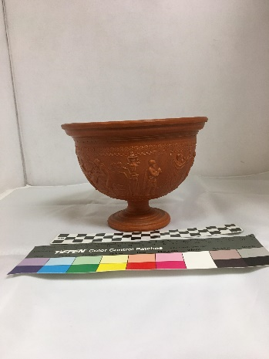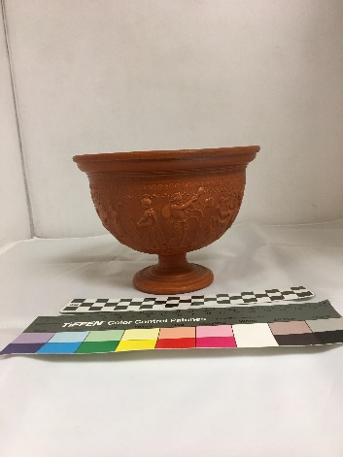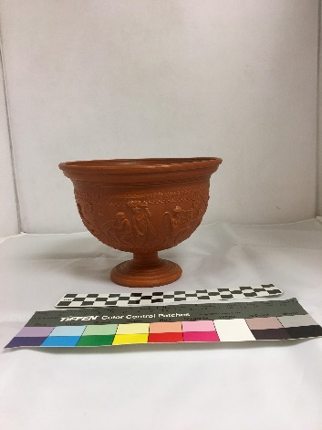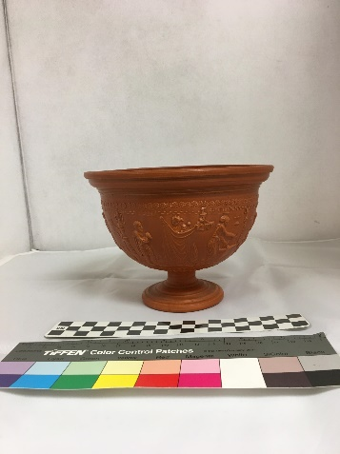
The terra sigillata is modeled after a Dragendorff 11 sigilatta from Southern Gaul that would have been popular between 40-55 AD. It is based on the relief-designed method of decorating pottery which was the most popular style of sigillata. This type of decorating was produced using a mold. The darker color with a dull reddish-brown slip indicates the influence of early South Gaulish pottery that was popular during the first century AD. The Dragendorff 11 was produced during 40-55 AD which aligns exactly with the influence and spread of South Gaulish pottery. Animal and human figures, like those on the model, first appeared on vessels in the first century with freestyle decoration that was typically in a frieze or band around the vessel rather than the later freestyle decoration covering the entire vessel after the first century. Early freestyle made use of scenery and grounded figures in a location that later shifted away from any set location. This model has more of an early freestyle influence with the people and animals set in a location based on a simple background. The more distinct outlines of the freestyle figures also indicate the influence of South Gaulish pottery as East Gaulish pottery has less distinct figures from the relief-design pottery.
This model is 16 cm wide by 12 cm tall with a 6 cm tall frieze. The frieze includes the words “PERENNI” and “CAPITINI” which indicates a year for the people in the town of Capizzi. Capizzi is a municipality of Messina in Sicily, Italy. The area has been called a number of names including Kapition and Capitium. The name for the people is Capitini which ties back to some of the original names.
The frieze also includes a variety of scenes around the vessel to represent a year for the people of Capizzi. There is an image of a man holding a baby followed by a woman holding a cloth and a baby. Next to the woman is a building in the background and then a man with a vine over a table. There is a different man then facing the man at the table playing a tibia (also known as an aulos: an instrument made out of two reed pipes and blown into to make music) and a woman with food in a basket held on her head looking over at the musician. Next to that are two angels around a center piece one playing a harp and the other playing a tibia. There is then a man holding an object resting on his should looking towards the angel. Past that man is a different man holding a sack over his shoulder and picking from a tall plant. Two men are then seen sacrificing a lamb or a pig with a bowl to catch the blood. Next to the sacrifice is a vase underneath a tree and next to a column which is next to the original man and baby.
Bibliography
Britannica, The Editors of Encyclopaedia. "Aulos." Encyclopædia Britannica. June 27, 2013. Accessed October 11, 2018. https://www.britannica.com/art/aulos.
"Capizzi." Wikipedia. August 22, 2018. Accessed October 11, 2018. https://it.wikipedia.org/wiki/Capizzi.
""Capizzi" on Revolvy.com." Revolvy. Accessed October 11, 2018. https://www.revolvy.com/page/Capizzi.
Caywood, Alyssa M. The Choice of Legions: The Terra Sigillata Collection at the Milwaukee Public Museum. Master's thesis, The University of Wisconsin-Milwaukee, 2011.

“"Capizzi" on Revolvy.com," Revolvy, accessed October 11, 2018, https://www.revolvy.com/page/Capizzi.
Ibid.
"Capizzi," Wikipedia, August 22, 2018, accessed October 11, 2018, https://it.wikipedia.org/wiki/Capizzi.
The Editors of Encyclopaedia Britannica, "Aulos," Encyclopædia Britannica, June 27, 2013, accessed October 11, 2018, https://www.britannica.com/art/aulos.

